Computer Language Coding Concepts

Private Objects in a Command Call in a Diagram
Private objects in a command call have been conceptually explained in the article Private Objects in a Command Call.

This article only illustrates how private objects in a command call look in a diagram.

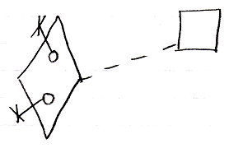

The diamond is a command call. Its definition is indicated with the dashed lin connecting it to the square, which is the definition. The circles inside the diamond are the private objects of the command call. The fact, that they are private is displayed with the object line and the cross it ends with indicating, that you can not reference these objects from the outside.

Another possible expression of the private objects is the following:

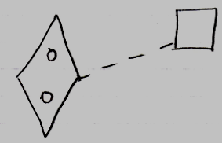

Because public object, parameters, always come with an indication of the parameter passing, you may not need to express the objects’ being private, because it would be obvious: if they do not have a parameter passing, then they are private.

The creation behavior of private objects in a command call will not be further explained with diagrams in this article. Refer to the article Creation Behavior of Command Callls in a Diagram for an illustration of how the creation behavior of command calls looks in a diagram.

See also: Private Objects in a Command Call,
Creation Behavior of Command Calls in a Diagram

Author & Copyright: Jan-Joost van Zon Date: August 9, 2008 – August 9, 2008 Location: Oosterhout, The Netherlands Status: Finished

